FORMAL PROJECT PROPOSAL
Name: | Elvis Mogaka
Programme: | MSc Data Science
Student ID: | 25067235
Module | UFCF9Y-60-M - Csct masters project 25jan_1
Project Title: | A research study on the detection of phishing emails using machine and deep learning models
Aim and scope: | The growing use of large language models (LLMs) makes it possible to generate phishing emails that are fluent, persuasive and less likely to contain obvious warning words. Conventional machine-learning detectors may rely on recurring lexical patterns, so their performance can decline when these cues are absent or deliberately altered. Research on LLM-generated and adversarial phishing identifies robustness, dataset quality, computational cost and explainability as continuing challenges (Kulal et al., 2025; Xue et al., 2026; Thakur et al., 2023).  This project will investigate how reliably selected machine-learning configurations distinguish phishing from legitimate emails when evaluated on an independent test set and under a controlled zero-cue stress test. A cleaned and balanced public email dataset will be transformed into a TF-IDF representation and used to compare thirteen model configurations across probabilistic, neighbourhood, linear, kernel, tree-based, ensemble, boosting, stacking and neural-network approaches. Evaluation will consider accuracy, precision, recall, specificity, F1-score and ROC-AUC, alongside computational practicality.  The project will also examine whether post-hoc explanations can make model outputs more useful for security analysis. The proposed LARX framework will translate phishing probabilities into risk tiers and human-readable, feature-based explanations. This scope addresses the gap between high benchmark scores and practical reliability when phishing language changes, while remaining feasible with a text-based, reproducible workflow (Champa et al., 2024; Eskandarian et al., 2026; Salloum et al., 2022).
Project objectives: | • Prepare a balanced, deduplicated corpus of legitimate and phishing emails and document the cleaning process.  • Preprocess email text and construct TF-IDF features for supervised classification.  • Train and compare thirteen machine-learning configurations using stratified cross-validation and an independent test set.  • Create the project artefact: a reproducible phishing-detection and explanation workflow incorporating LARX risk tiers and a zero-cue robustness test.
Expected project outcomes: | The main artefact will be a reproducible Python-based phishing email detection workflow. It will include data preparation, text normalization, TF-IDF feature extraction, model training and comparison, evaluation reporting, and an explanation component that converts predicted probabilities into risk categories with human-readable explanations. The workflow will record the software dependencies and experimental settings so that the analysis can be repeated.  The evaluation will identify which of the tested configurations offers the most appropriate balance of detection quality, false-positive control, robustness and computational practicality. The zero-cue stress test will remove selected prominent phishing-related lexical indicators from test messages and measure the change in performance. The results will not assume that a model is robust simply because it performs well on ordinary test data; instead, performance changes and limitations will be reported explicitly.
Brief review of relevant literature: | Existing studies provide the methodological and empirical foundation for the proposed work. Salloum et al. (2022) review NLP approaches to phishing detection and help position TF-IDF and text classification as established baselines. Champa, Rabbi and Zibran (2024) emphasize careful curation, decoding and deduplication, informing the dataset-preparation stage. Alhuzali et al. (2025) compare models across multiple datasets and motivate systematic evaluation rather than reliance on one headline accuracy score.  Kulal et al. (2025) examine conventional, LLM-generated and adversarially modified phishing emails, directly informing the robustness motivation. Xue et al. (2026) discuss explainable and adaptive detection against context-aware LLM phishing, while Tóth, Bisztray and Dubniczky (2025) examine phishing, spam and rephrased email content. These studies support the focus on changed language and the limits of static cues. Eskandarian et al. (2026) highlight inference speed and model footprint, which justify recording computational practicality alongside predictive performance.  Further comparisons will be drawn from Altwaijry et al. (2024), Atawneh and Aljehani (2023), Chinta et al. (2025), Gualberto et al. (2020), Lee et al. (2021), Li, Cheng, Wang and Sun (2020), Maeli and Surwade (2026), Mughaid et al. (2022), Atlam and Oluwatimilehin (2022), Tan et al. (2023), Thakur et al. (2023) and Verma, Goyal and Gigras (2020). Together, these sources inform model selection, feature engineering, false-positive considerations, explainability and deployment constraints. Findings reported in these papers will be treated as prior-study results, not as results of the proposed experiment.
References: | Alhuzali, A., Alloqmani, A., Aljabri, M. and Alharbi, F. (2025) ‘In-Depth Analysis of Phishing Email Detection: Evaluating the Performance of Machine Learning and Deep Learning Models Across Multiple Datasets’, Applied Sciences, 15(6), p. 3396.  Altwaijry, N., Al-Turaiki, I., Alotaibi, R. and Alakeel, F. (2024) ‘Advancing phishing email detection: a comparative study of deep learning models’, Sensors, 24(7), p. 2077.  Atawneh, S. and Aljehani, H. (2023) ‘Phishing email detection model using deep learning’, Electronics, 12(20), p. 4261.  Atlam, H.F. and Oluwatimilehin, O. (2022) ‘Business email compromise phishing detection based on machine learning: a systematic literature review’, Electronics, 12(1), p. 42.  Champa, A.I., Rabbi, M.F. and Zibran, M.F. (2024) ‘Curated Datasets and Feature Analysis for Phishing Email Detection with Machine Learning’, in 2024 IEEE 3rd International Conference on Computing and Machine Intelligence (ICMI). Pocatello, ID, USA: IEEE, pp. 1–7.  Chinta, P.C.R., Moore, C.S., Karaka, L.M., Sakuru, M., Bodepudi, V. and Maka, S.R. (2025) ‘Building an intelligent phishing email detection system using machine learning and feature engineering’, European Journal of Applied Science, Engineering and Technology, 3(2), pp. 41–54.  Eskandarian, M. et al. (2026) ‘A lightweight defense mechanism against next-generation of phishing emails using distilled attention-augmented BiLSTM’, Journal of Information Security and Applications, 101, p. 104552.  Gualberto, E.S. et al. (2020) ‘The answer is in the text: Multi-stage methods for phishing detection based on feature engineering’, IEEE Access, 8, pp. 223529–223547.  Kulal, D.H., Arannonu, C.P., Anwar, A., Rastogi, N. and Niyaz, Q. (2025) ‘Robust ML-based Detection of Conventional, LLM-Generated, and Adversarial Phishing Emails Using Advanced Text Preprocessing’, arXiv preprint arXiv:2510.11915v1.  Lee, J. et al. (2021) ‘D-Fence: a flexible, efficient, and comprehensive phishing email detection system’, in 2021 IEEE European Symposium on Security and Privacy (EuroS&P). IEEE, pp. 578–597.  Li, Q., Cheng, M., Wang, J. and Sun, B. (2020) ‘LSTM based phishing detection for big email data’, IEEE Transactions on Big Data, 8(1), pp. 278–288.  Maeli, S.A. and Surwade, A.U. (2026) ‘Detecting Phishing Emails Using GloVe Word Embeddings and Ensemble Machine Learning Model’, IET Information Security, 2026(1), p. 2558485.  Mughaid, A. et al. (2022) ‘An intelligent cyber security phishing detection system using deep learning techniques’, Cluster Computing, 25(6), pp. 3819–3828.  Salloum, S., Gaber, T., Vadera, S. and Shaalan, K. (2022) ‘A systematic literature review on phishing email detection using natural language processing techniques’, IEEE Access, 10, pp. 65703–65727.  Tan, C.C.L. et al. (2023) ‘Hybrid phishing detection using joint visual and textual identity’, Expert Systems with Applications, 220, p. 119723.  Thakur, K., Ali, M.L., Obaidat, M.A. and Kamruzzaman, A. (2023) ‘A systematic review on deep-learning-based phishing email detection’, Electronics, 12(21), p. 4545.  Tóth, R., Bisztray, T. and Dubniczky, R.A. (2025) ‘Constructing and Benchmarking: a Labeled Email Dataset for Text-Based Phishing and Spam Detection Framework’, arXiv preprint arXiv:2511.21448v1.  Verma, P., Goyal, A. and Gigras, Y. (2020) ‘Email phishing: Text classification using natural language processing’, Computer Science and Information Technologies, 1(1), pp. 1–12.  Xue, Y., Spero, E., Woo, M.W., Gao, W. and Russello, G. (2026) ‘MultiPhishGuard: An Explainable and Adaptive Multi-Agent LLM System for Phishing Email Detection’, arXiv preprint arXiv:2505.23803v2.
Testing and Evaluation: | Testing will use a stratified train/test split and stratified cross-validation on the training data, with preprocessing and feature fitting performed without leakage from the test set. Models will be compared using accuracy, precision, recall, specificity, F1-score and ROC-AUC, with confusion matrices used to inspect false positives and false negatives. The strongest-performing configurations will then be assessed using the predefined zero-cue stress test; the absolute and relative changes in metrics will be reported against the unmodified test set. The workflow will also be assessed for execution time, memory or resource requirements where practical, reproducibility, and the clarity and consistency of LARX explanations. Success will be judged against transparent criteria and documented limitations, rather than a pre-assumed target accuracy.
Ethical considerations: | The project uses a publicly available research dataset and secondary analysis of existing email text; it does not require interviews, surveys or direct participation by people. Email content may nevertheless contain sensitive information, so data will be used only for the stated defensive research purpose, and the analysis will not attempt to identify, contact or profile individuals. Data will be stored securely, access will be limited to the researcher, and any local copies will be retained only as required for assessment and reproducibility before deletion in accordance with institutional guidance. Dataset terms, software licences, academic integrity and the institution’s ethics requirements will be followed. The source document states that ethics approval was completed; this should be confirmed against the relevant approval record before submission.
Project plan: | 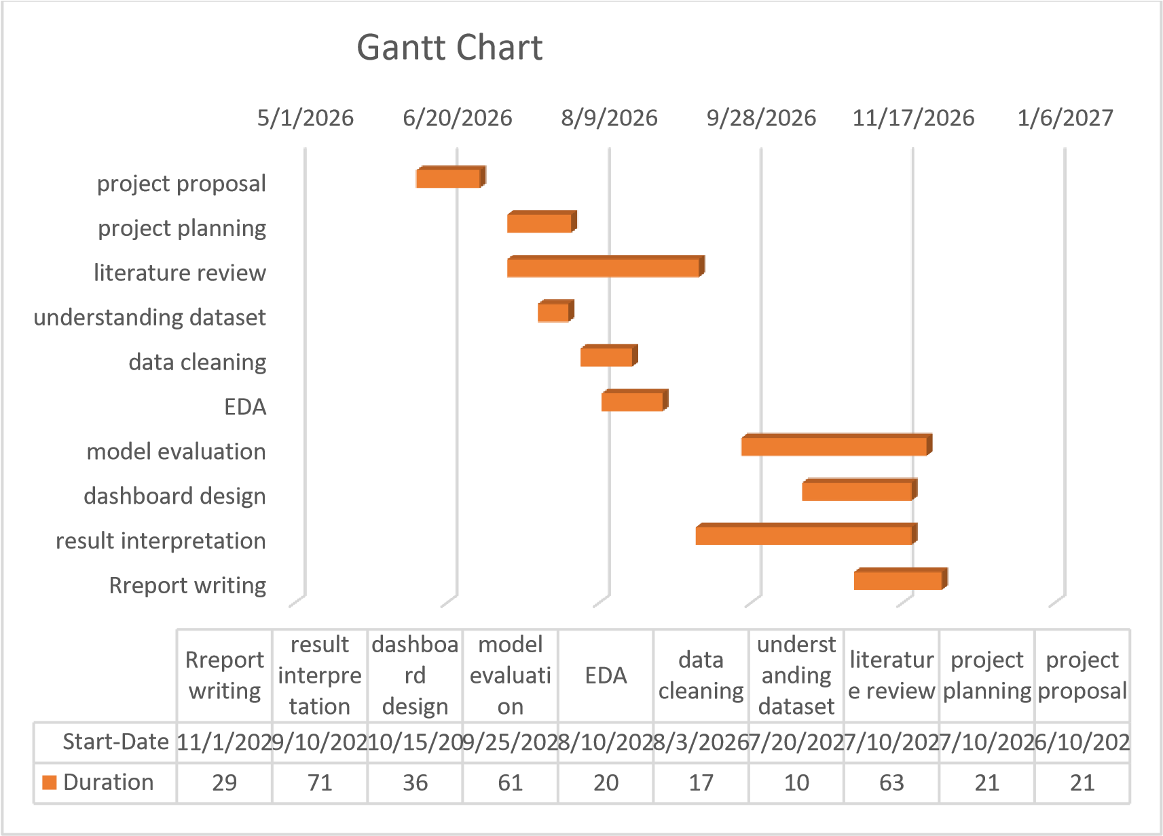
Signature: | Signature:  Date: 22/10/2026

